Hangman.java was my final project as a student of CS 114, an LDSBC students’ first look into learning and working with a software-coding platform. This was designed to have us utilize all we had learned up until this point. We were only told to create a program that could take input, record wrong letters, and put together a text-stream that signified the progression to hangman/7-strikes-you’re-out.

The program takes word-list.txt, puts in into an ArrayList<> and creates a random index into the array. This word is the basis of a round of Hang-man. You will see that for this gameplay example I included (line 25-27) code that only allows 16-letter words (the longest found in word-list.txt). I find this makes for both more interesting gameplay and easier solving of the word.

In the beginning example I show some responses to invalid input.

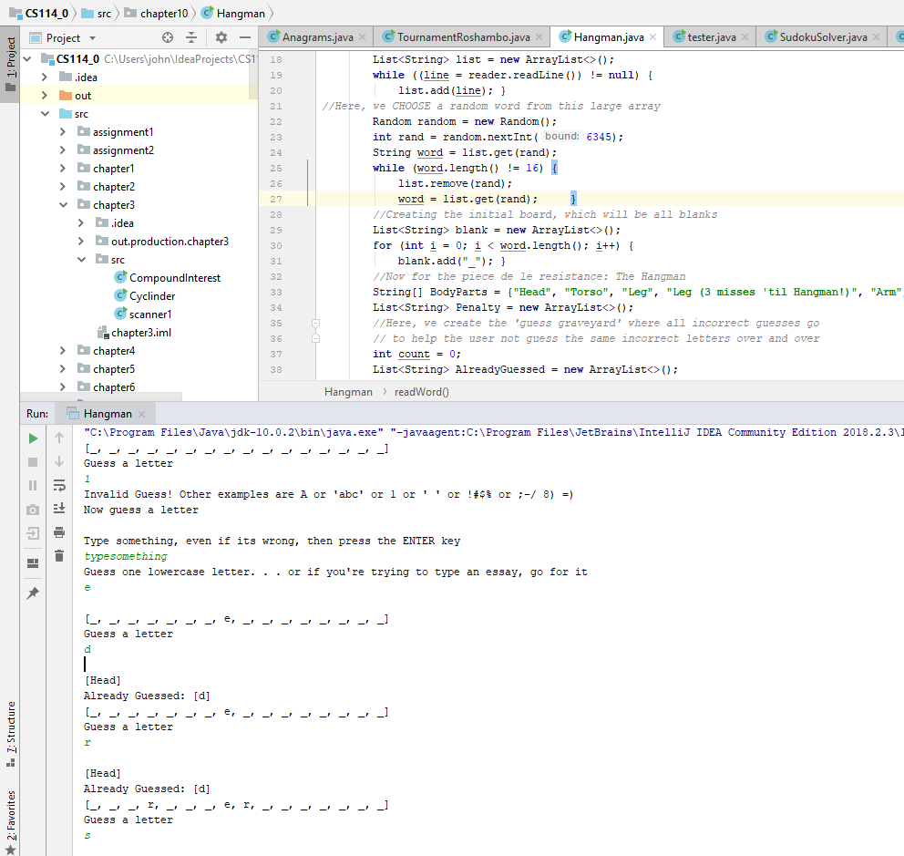

Of course now I would have used a regular expression for simplicity’s sake. See the progression of the BodyParts array and catalogue of letters already guessed as the puzzle approaches solution.

